MORNING WORSHIP SERVICE
Sept 11, 2016

Opening “America the Beautiful” 630

Opening Prayer/Announcements
K s b c

Keeping His Word through Sunday School, Bible Study and Church Attendance/Worship

Sunday School Bible Studies for September:

Sept 4th One Great Creator Ps 33:6-9,13-15; Col. 1:15-17
Sept 11th One Great Purpose Isaiah 43:1-7
Sept 18th One Great Problem Romans 3:9-12,19-20,23
Sept 25th One Great Savior Romans 5:6-11

9:45 a.m. each Sunday – A place for everyone

Worship Hymns “Seek Ye First” 478
“Freely, Freely” 273
“Stand Up, Stand Up for Jesus” 485
“Amazing Grace” 330
“My Chains Are Gone”

Offering/Offertory

Special Music Bro. David Atwood

Message Bro. David Atwood

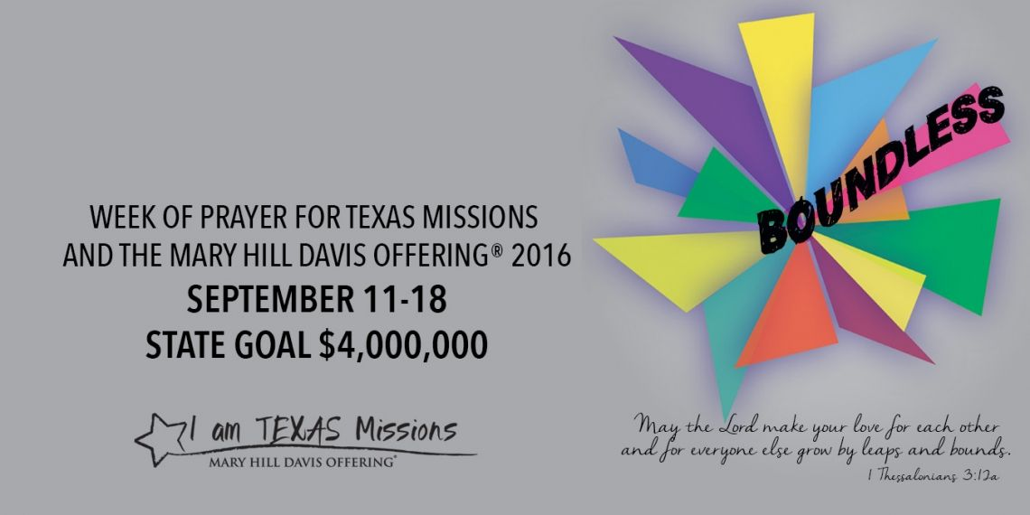

Invitation “I Have Decided to Follow Jesus” 305

Closing Prayer

Evening Service @ 6:00pm

NURSERY – available for children age 0 to Kindergarten
Terri Edwards, Jana Moore

Hostesses for September Ushers for September
Brenda Williams, Evelyn Robinson, Jack Radford, Tom Veilleux,
Judy Broussard Joe Wilson, Wayne Marecle

Immediate Need Prayer List
Prayer & Request Information

(Please complete name & address information on reverse side)

❑ I would like to speak with the Pastor.

❑ I would like more information on this church.

❑ I have Prayer Requests or Needs

Date:

Permission to Publicize:
Church Bulletin  Yes  No
Email Prayer Chain  Yes  No

Prayer Request:

Prayer For
Name
Address
Phone

Given By
Name
Address
Phone
Please Contact By

❑ Card  Phone  Visit

Comments

Pray for unsaid fears and concerns

Pray for Karlie Griffith as she recovers from surgery

